**Linux Assignment Set 3**

1. **Create a file like nano file1.txt**

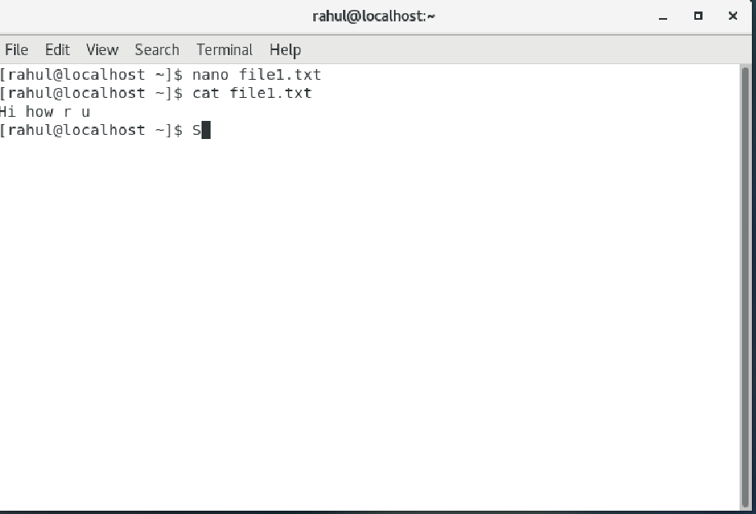

Here we have created a file using nano file1.txt

1. **Copy data from file1 to file2**

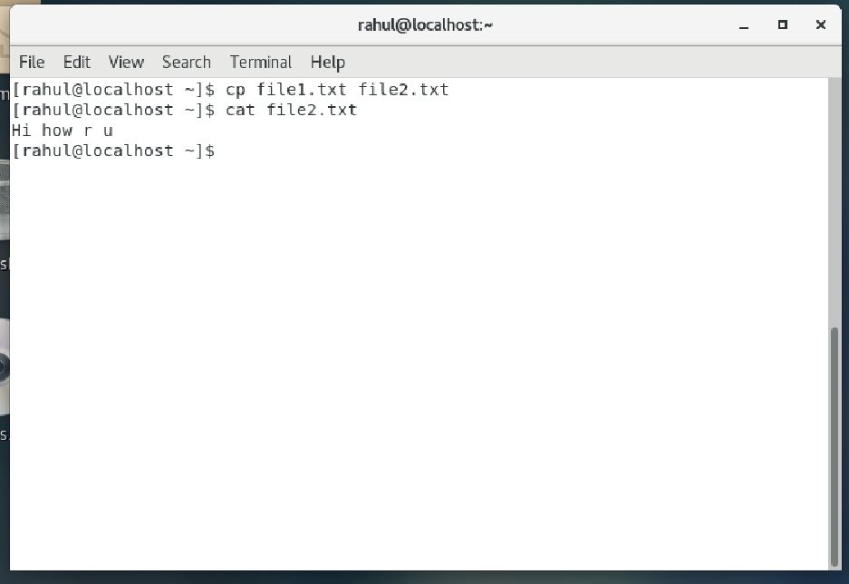

Here we have copied data from file1 to file 2 by using the cp command

1. **Move the file2.txt to new folder /home**

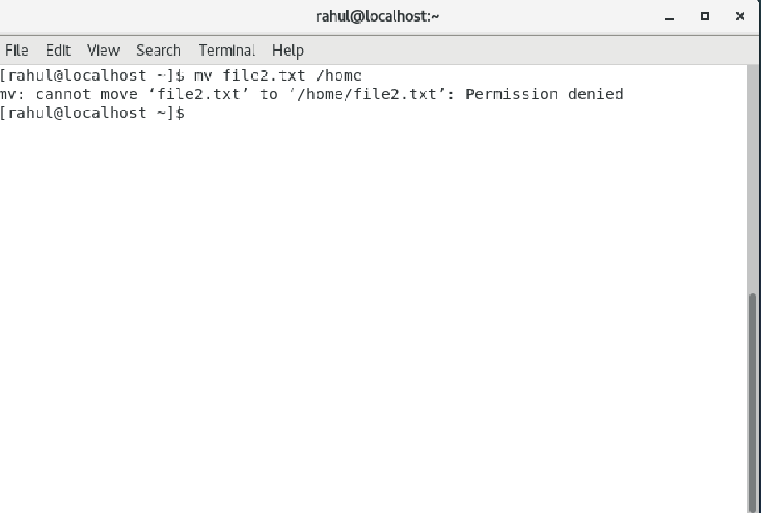

We cannot move the file2 as permission is denied.

1. **Create a new file3.txt and file4.txt in home directory and add content in it.**

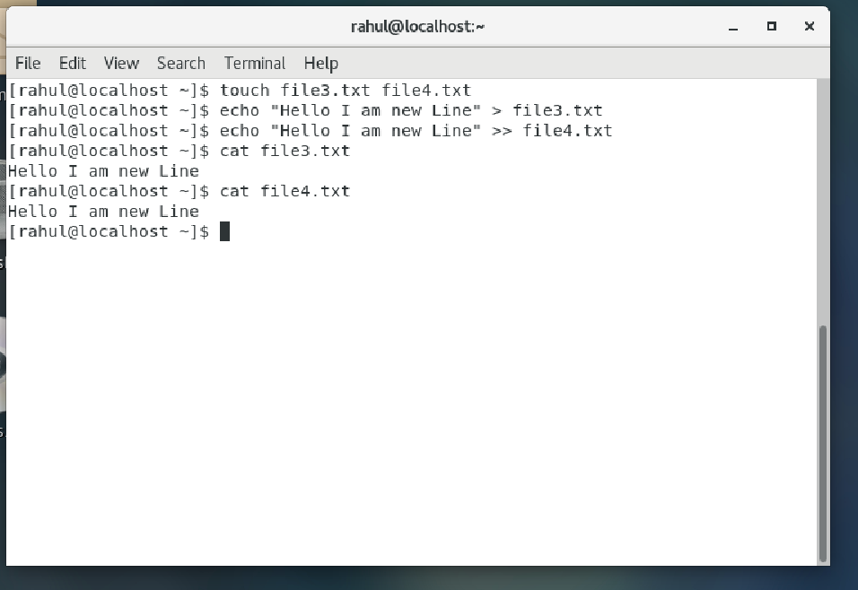

There is no notable difference between the two files as the are new files and the output is same.

But > will redirect the output and overwrite the file

And >> will append an already present file and won’t overwrite the file

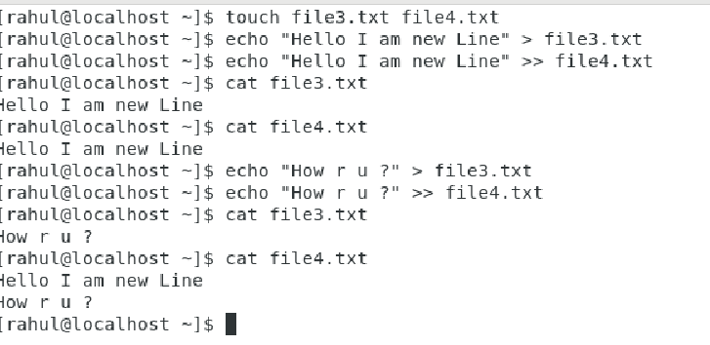

1. **For remove a file or directory**

* Lets remove the file file3.txt

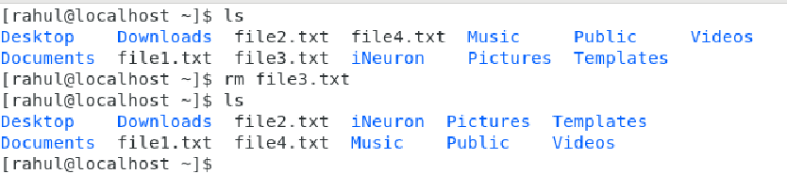

* Lets remove the directory iNeuron

